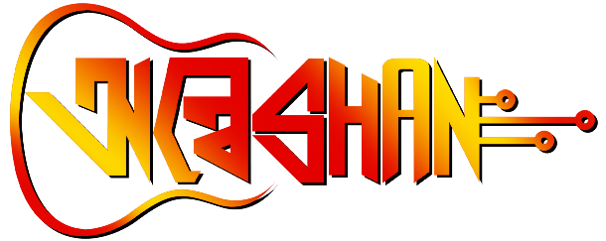

**DANCE**

Contact: Srija Porel (6291465607),

Swati Sikder (7384584305)

**Description:**

Dance is the joy of movement and the heart of life and dancers don't need wings to fly. In the competition participants can perform as solo as well as in groups (not more than five). Classical, semi classical and contemporary form of dance are only accepted. Participants are requested to approve their track (in which they are going to perform) by sending it to any of their coordinators. Time limit for each performance should not be more than 6 minutes. Participants should be responsible for their props, hair, dress and makeup. So, get ready to groove and showcase your rhythmic talent at our university's upcoming tech and cultural fest! Step onto the stage and mesmerize the audience with your moves, creativity, and passion for dance!

Guidelines

**Category of Performance:**

1. Group: Maximum 5 participants
2. Solo

**Types of Performance:**

1. Classical
2. Semi-classical
3. Fusion

**Rules and Regulations:**

1. Approve your song by stating the name of your song to your coordinators.
2. After Approval submit the song in Mp3 to your coordinators.
3. Time Limit – Maximum 6 min. for each performance.
4. The participant has to bring their own props.
5. Participant should be responsible for their hair, dress, Makeup.
6. There will be Screening before the final performance.
7. On the final day of the Dance event participant should be provided with refreshments.

All the participants are requested to abide by these rules otherwise it

may result in disqualification. For further clarification please contact to

the event organizers.

We appreciate your involvement and eagerly anticipate your

participation!